
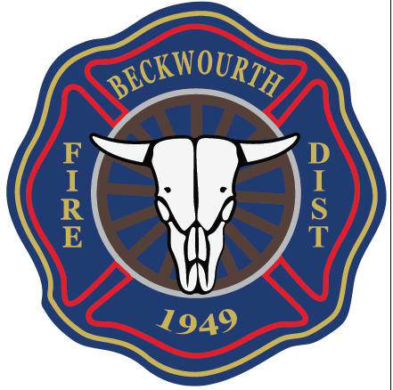

Will be hosting
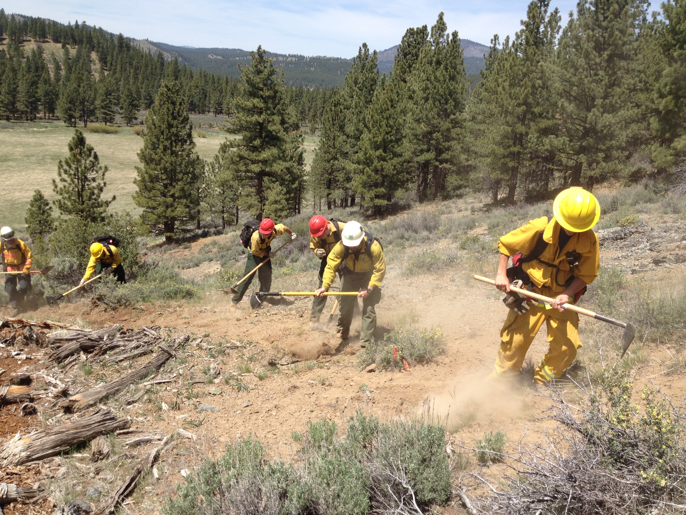
BASIC 32

This is a 40 hour class designed for firefighters who will be responding to wildland fires.
S-130, S-133 and S-190 covers the basics of wildland fire behavior, weather, fire shelters, establishing hand lines and wet lines.
Students will need to bring their wildland turnouts and web gear. A limited supply will be available for students to borrow.

Dates:
Day 1, Orientation Class will be held at the Beckwourth Fire District, Station 1, 180 Main St. Beckwourth April 4th, 2016 6:00pm – 6:30 pm. Handouts and Home Study instruction will be given out at that time.
Day 2, Field Exercise will be Sunday, May 1st, 2016 7:30am – 5:00pm
Bring a Lunch

There is no cost for this class, Class size is limited.
Please call 832-1008 to sign up.

