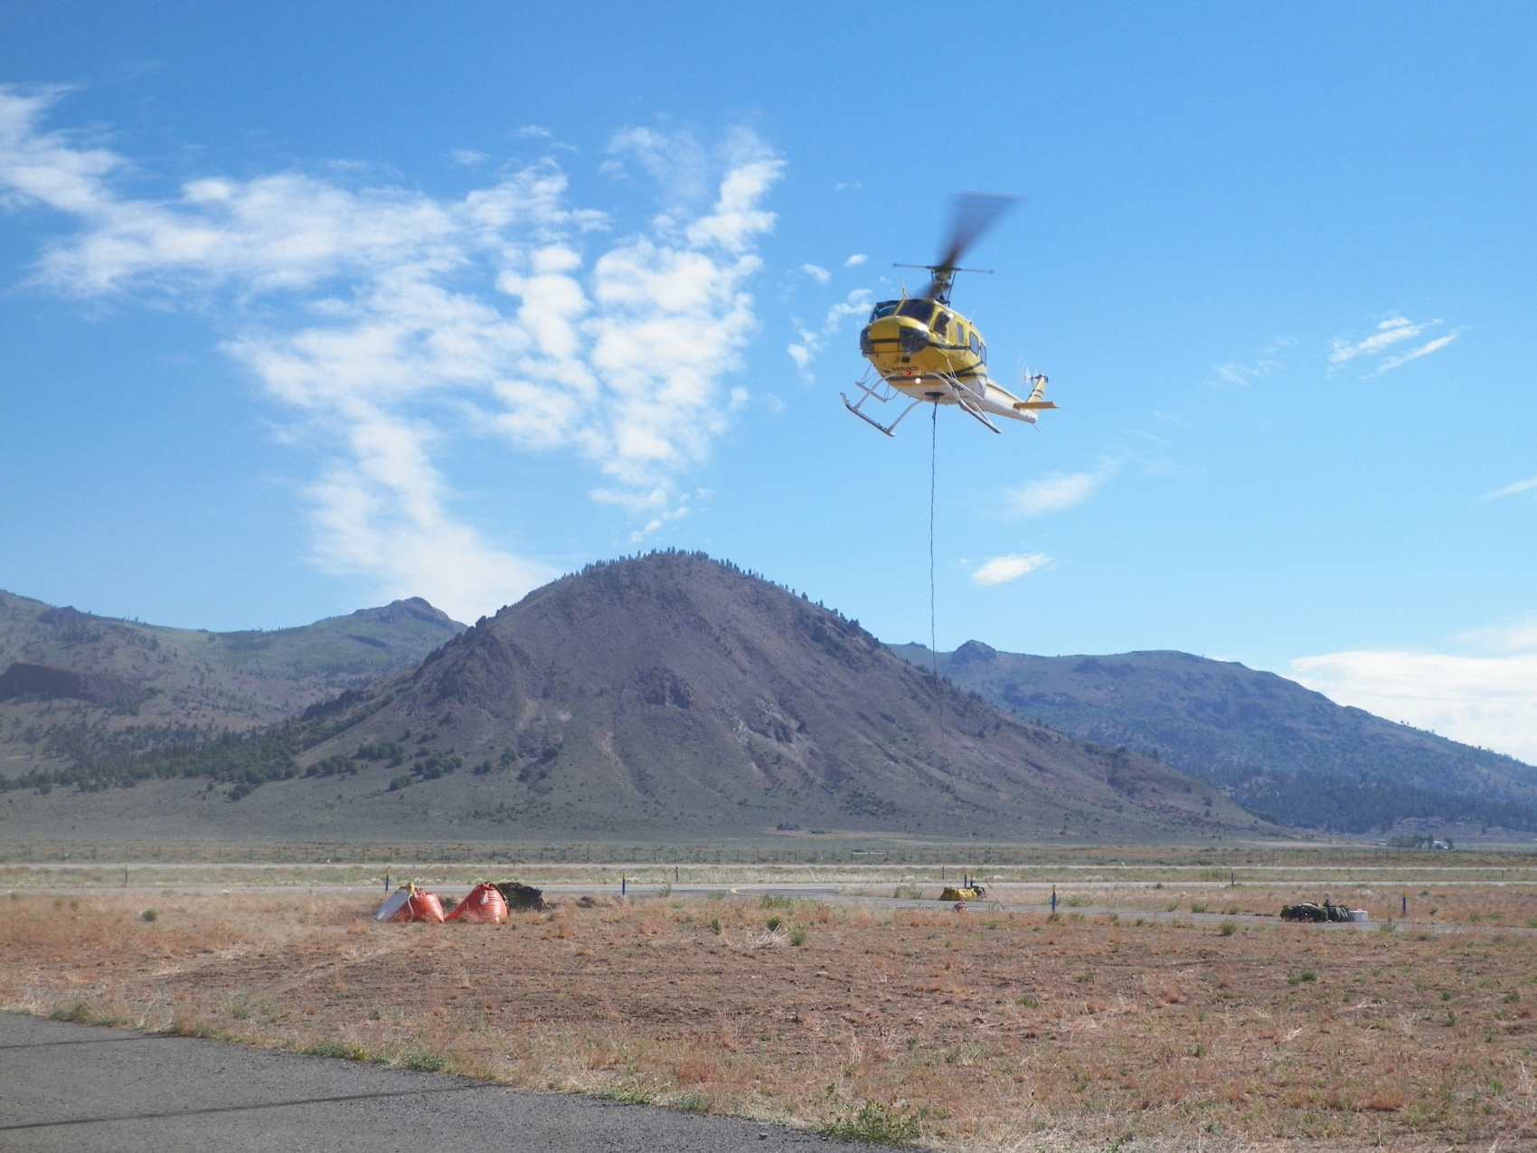
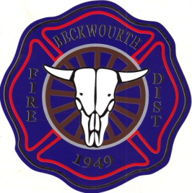
Beckwourth Fire
Will be hosting

S-270
BASIC AIR OPERATIONS

This is the air operations class that is a prerequisite for all Fireline EMTs and Paramedics.
When: June 23rd, 24th, and 25th
Schedule: 23rd and 24th, 1800-2130, Classroom
25th, 0900-1500, Airport
Where: Beckwourth Fire, Station 1
180 Main St. Beckwourth
NWCG and CEUs will be provided
RSVP is Mandatory, 832-1008, Space is limited.
There is no charge for this class.
Bring your own lunch.

